Appendix 7

The Mallory Connection

Author’s Note: This paper was written in 2006. A lot of additional information has become available since then. As a result some of the speculations and proposals presented below are dated. The connection wasn’t between E.V. Gray and ‘Boot’ Mallory but was rather with Marvin Cole - the real developer of this Free-Energy. E.V. Gray was the salesman in this partnership who probably didn’t know how an ignition coil operated; much less discuss its construction specifications. However, Richard Hackenberger said that this transformer was the heart of the technology. No wonder Marvin Cole searched for expertise in high voltage transformer fabrication and found it with this family comapny.

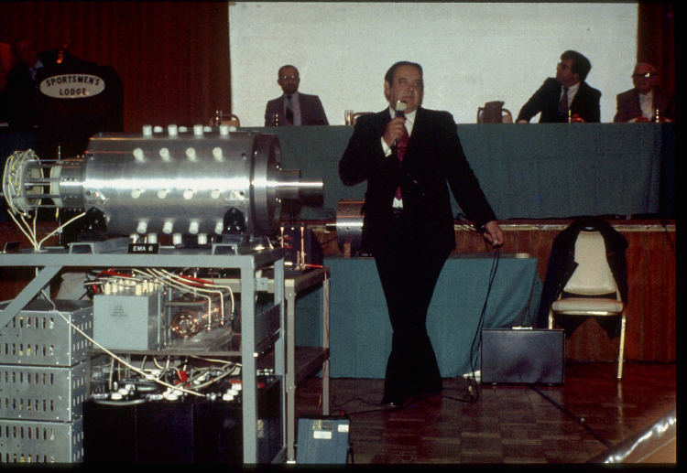

E.V. Gray Free-energy Engine EMA6 Jan. 9, 1976 – Photo by Tom Valentine

Consider the now classic 1976 photo (above) of Mr. E.V. Gray demonstrating his EMA6 motor to investors at the Sportsman Lodge in Burbank, CA. This photo was taken by Tom Valentine, who wrote a series of informative articles about the EV Gray saga. Dr. Peter Lindemann received this original film from Mr. Valentine to support Peter’s research for his book “The Free Energy Secrets of Cold Electricity”.

In a fruitful attempt to extract additional technical information from this historical photo Dr. Lindemann arranged to have it digitally enhanced. One of the goals of this effort was to decipher the writing on the large gray storage capacitor directly under the motor. It read:
MALLORY
MADE IN U.S.A.
TYPE TVC-606
5.0 MFD 5000 VDC

Mallory is a well known name in the field of electronics. When one thinks of Mallory today they generally think of the premium large blue electrolytic filter capacitors that dominated the high end linear power supply market in the 70’s and 80’s. At its peak, the P.R. Mallory Company was a power house of US made electrical components. Not only did they make several lines of capacitors but they also made Battery Chargers, Resistors, Rheostats, Rectifiers, Switches, UHF Converters, Noise Filters, Soldering Iron Tips, and Special Television Components. Their 1955 Catalog was 60 pages long.
Mr. P.G. Mallory started out in 1916 with the invention of the Mercury Battery. By 1965 the company developed the well known Duracell Alkaline battery.

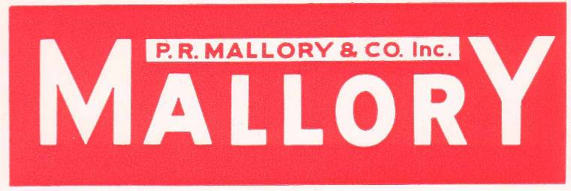

The North America Capacitor Company (NACC) is headquartered in Indianapolis, Indiana. Today, NACC continues to manufacture and market Mallory capacitors at its modern manufacturing and warehouse facilities located in Greencastle, Indiana and Glasgow, Kentucky

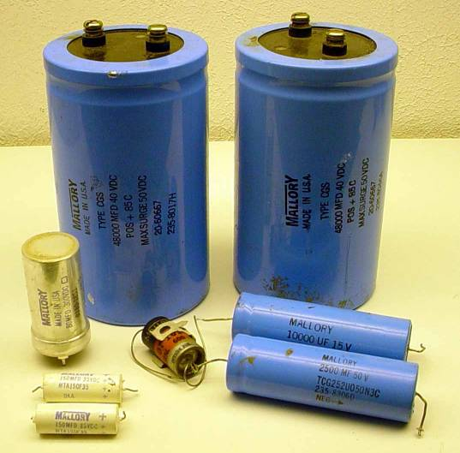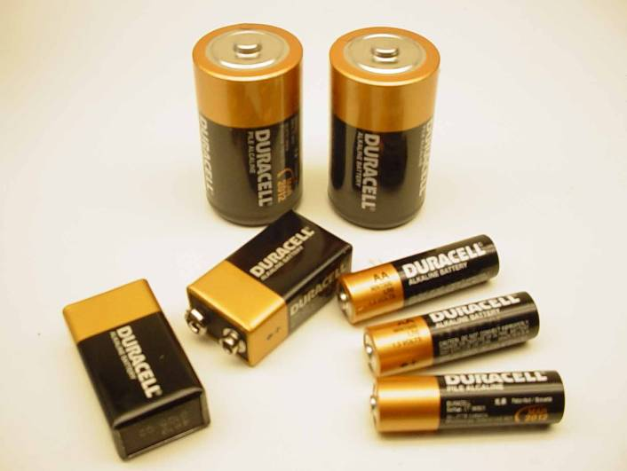

. Used Mallory Capacitors from Author’s Duracell Batteries from Author’s . Experimental Parts Reserve Wife’s Hardware Drawer

Another important Mallory invention, very relative to the EV Gray technology, was the 1920’s development of the “Elkonode”, better known back then as simply the “vibrator”. Today this device is hardly known at all. In its time it served as a vital sub-system in early DC converters. These were used to raise the low voltage levels of storage batteries to the operating levels required by vacuum tubes, which was 200 to 500 VDC. This now forgotten electro-mechanical component was the functional equivalent of two push-pull power transistors in a modern switch-mode power supply. At the time, when it came to mobile electronics there were two choices. 1) A vibrator based power converter, or 2) A heavy dynamo-motor base converter. For applications under 30 watts the vibrator approach was smaller, lighter, cheaper, and more efficient than the alternative. Therefore, the military had a serious interest this technology, but it was in the mass market demand for small vacuum tube car radios where the real money was made.

The P.G. Mallory Co. almost completely dominated the top end power vibrator market for 40 years and was responsible for almost all of the performance improvements through the 40’s and 50’s. But, all good things must end. This lucrative product line came to a screeching halt in 1957 with the development of low voltage signal and power transistors. But Mallory still managed to keep a cutting edge in many of its other market areas for several years after that.

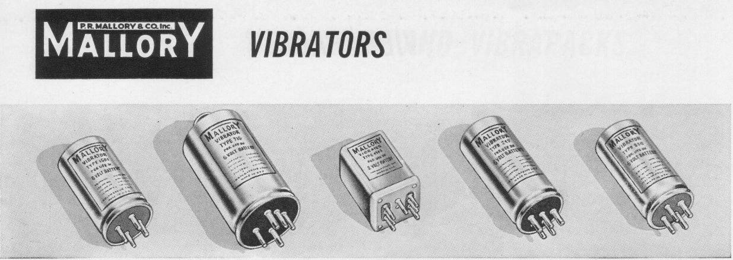

So, it is no big surprise when one reads in the 1973 Scagnetti EV Gray article:

The Engine that Runs Itself
By Jack Scagnetti from `Probe The Unknown' in June 1973.

“Mallory Electric Corporation of Carson City, Nevada, has also made a major contribution toward the design of the electronic pulsing system.”

It’s all pretty obvious that Mr. Gray had a huge investment in Mallory type components. If his invention did become main stream then the Mallory Co. would have had first shot at a huge new automotive market. Each new vehicle would need between $300 - $600 worth of rugged HV storage capacitors, not to mention an investment of twice that much for vibrator power converters or their equivalent solid state replacements, which Mallory made also.

It is real easy to see how Mr. Gray could have convinced a few executives at Mallory how it would be in their best interests to help him out financially, or at least provide him with a little hardware donation from their Vibrapack division in Irvine CA. Mr. Grays impressive “hands-on” demonstrations were known to be very effective at convincing technical professionals that he was on to something big, providing that he was ever allowed the opportunity to make such presentation to a real decision maker. Most likely some inspired and insightful 3rd level staff person managed to fix him up with a pickup load of surplus vibrator converters that were, or would be, completely obsolete.

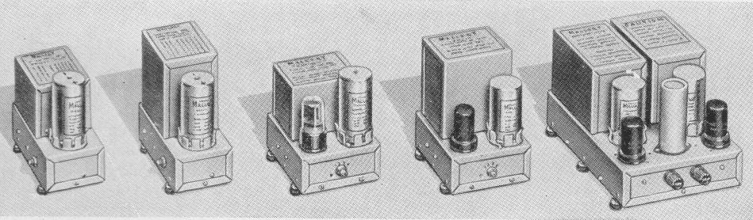

Examples of the P.R. Mallory line of “Vibrapacks” (DC Converters) from 1955 Catalog
All models have a 30 Watt power rating except the one on the far right which is rated at 60 Watts

But this story has an important twist in it……..

The Mallory Company that gave Mr. Gray enough money to make mention of it in the above magazine article was not the P. G. Mallory & Company Inc. but the Mallory Electric Company of Carson City, Nevada, designers and manufactures of a multitude of OEM and after-market automotive ignition systems.

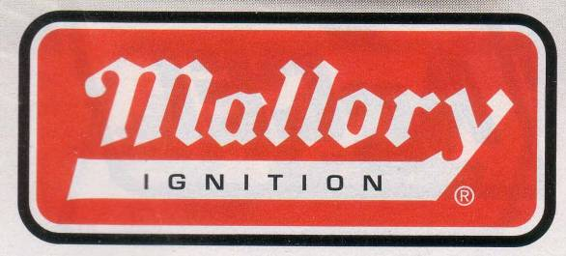

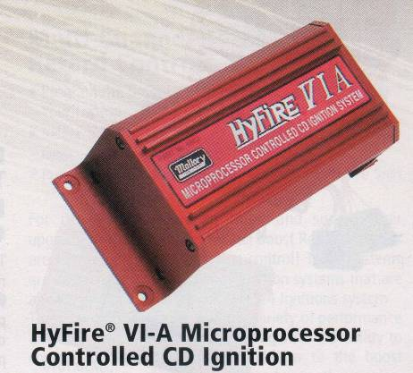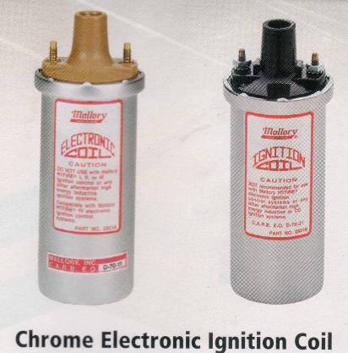

A Small Sample of modern Mallory brand name After Market Ignition Products 2006

Mr. Marion Mallory was the rare sort of independent individual who would start a company on Friday the 13th in February of 1925. He was a self-made inventor with a 4th grade education who was not only brilliant at his craft but also had what it takes to manage a business. If he ever met Mr. Gray face to face the two men would have had a lot in common, especially from a “hands-on” creative energy standpoint. Mr. Mallory made his money in a variety of automotive, motor cycle and marine ignition systems. For years he was the main supplier to the Ford Motor Company for ignition distributors and their upgrades. He received about 30 US and 10 international patents for a multitude of significant improvements in ignition technology, both in electrical and mechanical systems. He was darn good at business, but his personal weakness was high performance auto racing. The market for race car parts is not very big, but the activity it supports is very addictive. Marion sponsored as many as three teams a year in the various classes of professional auto racing. It is also been said that Mr. Mallory looked for and hired like minded creative engineers and technicians. He also despised the union worker mentality that had become so adversarial in the Detroit area between the 50’s and 60’s.

Mr. Mallory finally got fed up with the stifling and counter-productive demands of the United Auto Workers Union. In a rare act of individualism he decided to make arrangements to move his entire company, lock, stock and, ignition coils to Carson City, NV. At this time Marion was getting along in years and unfortunately never made the move. He died in 1968 at the age of 70. His son ‘Boot’ Mallory was then handed the reins of this privately held company. ‘Boot’ terminated all the Union labor and kept 10 of the most productive engineers and technicians who were willing to relocate to the new factory. This facility was opened in 1969. From all accounts the “heir apparent” and only son was very motivated, technically competent, savvy at business, and like his father hopelessly addicted to high performance auto racing.

Given the timing of events it is most likely that Mr. Gray never met Marion Mallory. It is almost certain that the connection to the Mallory Company was entirely between Mr. Gray and ‘Boot’ Mallory. This was also helped by the fact these two men were about the same age with Mr. Gray being 5 years older.

For their entire business careers Marion and ‘Boot’ Mallory were always on the look out for improved ignition systems, both for good business practice and, of course, a desire to sport the fastest cars at the race track. Their knowledge base and field experience covered all approaches to ignition system design, both in the electrical and mechanical areas. It is interesting to note that they developed and manufactured magneto systems as well as traditional distributor systems. Understand that these two technologies are vastly different to each other.

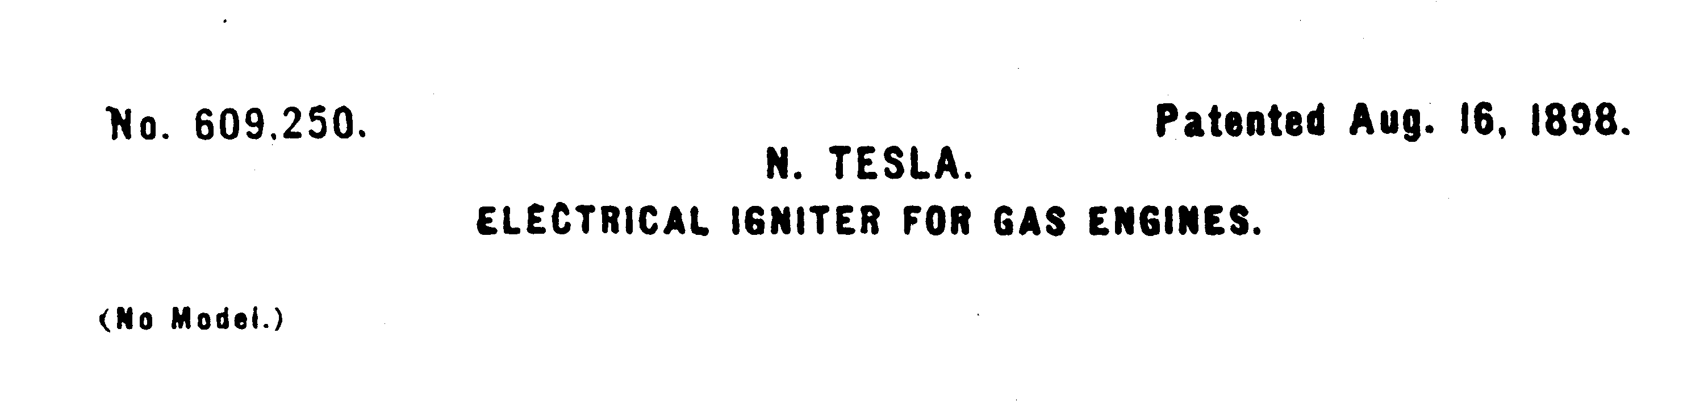
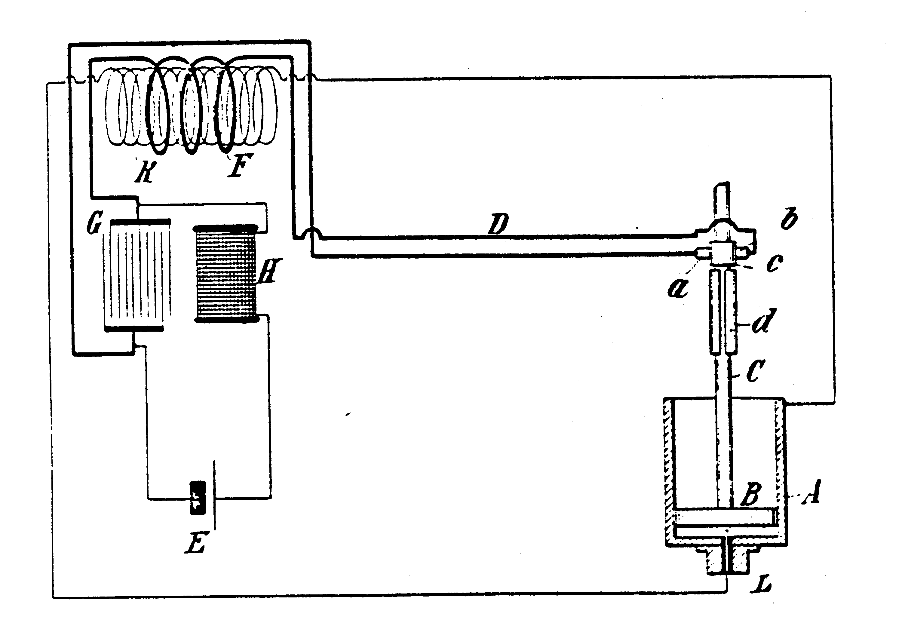

In the auto racing circles it has always been known that capacitive discharge ignitions system are far superior to the limitations of the standard Kettering induction system, especially at high RPM. Dr. Tesla patented the first CD ignition system as early as 1898 but it was never produced because of serious design and component limitations. Marion Mallory and his engineers did get a working capacitive-discharge system finally connected to a race car engine in 1948. This first design was built employing a thyratron gas tube and vacuum-tube circuitry. As a result, it was costly, bulky, and unwieldy, not to mention fragile and economical unfeasible. But despite all of its failings the Capacitive Discharge Systems (CD) clearly showed its superior performance in the laboratory and on the track. Had it not been for the random and sudden failure of these alpha-test units (because of vibration) they might have still been used in professional auto racing, regardless of their unit cost.

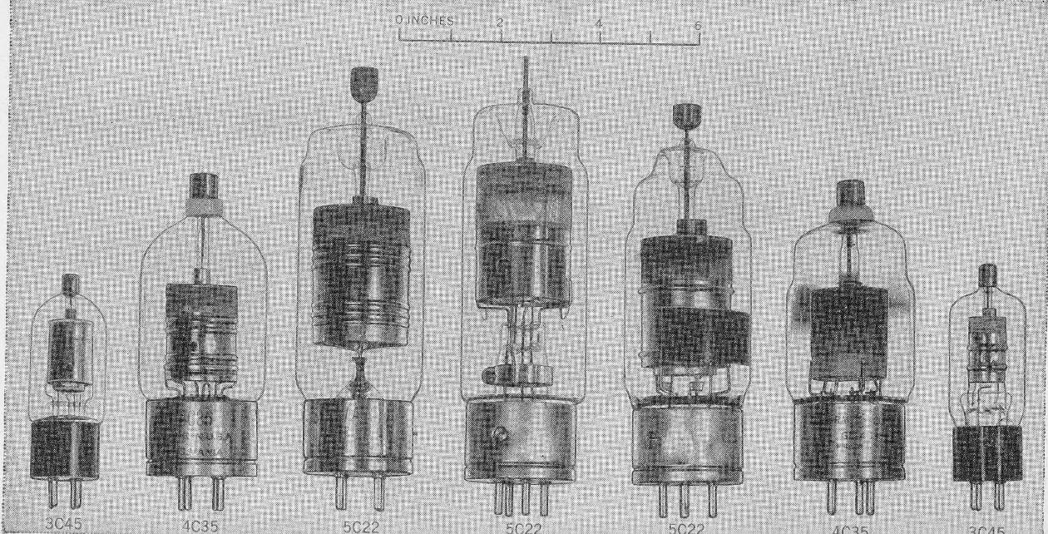

Glass Hydrogen Thyratrons of the 40’s
From “Pulse Generators” Radiation Laboratory MIT 1948

Two new technologies were needed to get CD systems off the ground.

1) Some method to boost the 6 or 12 VDC storage battery voltage to the 400-500 Volt range with an available current of at least 100 mA. (40-50 Watts)

2) A component or technique that would replace the bulky, fragile, and power hungry thyratron that acted as the master timing control switch.

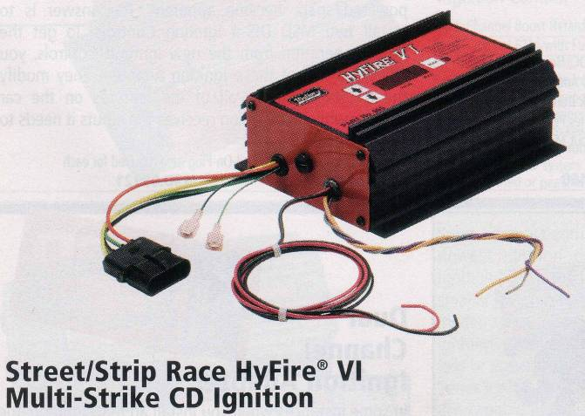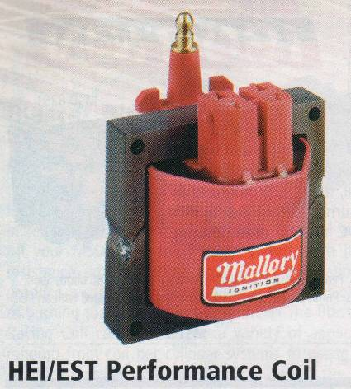

Modern Mallory “2006” Capacitor Discharge Ignition Components

Both solutions came along about the same time. Power transistors became available to the aerospace industry in 1954. These allowed the development of early push-pull switched mode power supplies whose output were way beyond what a mechanical power vibrator could deliver (up to 90 Watts initially). Complete transistor converters were available to the hobbyist in early 1958. So we can assume that prototype power transistors were available to industry in about 1955.

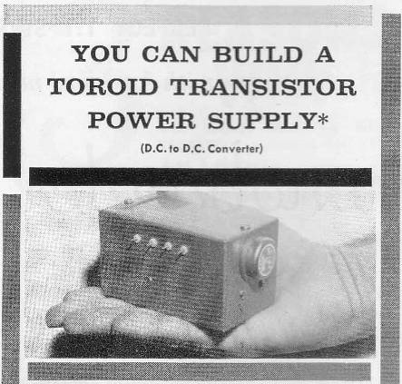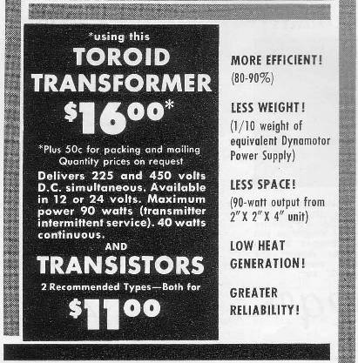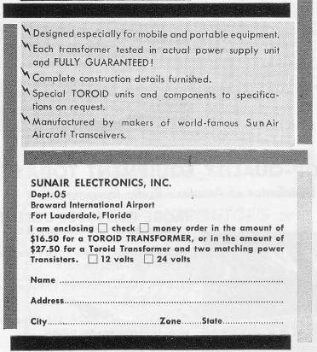

Early advertisement for a 90 Watt (pulsed) Hobbyist 12V to 450V DC Converter
From “QST” magazine January 1958
(Notice size reduction when compared to the 60 Watt Vibrapack)

The second critical breakthrough came with the invention of the Thyristor or Silicon Controlled Rectifier (SCR) by Bell Labs in 1957. General Electric quickly bought the rights for this promising technology and wasted no time in bringing it into production. The manufacture of solid state power rectifiers and transistors was already well underway, so, building an SCR’s using the existing production equipment was a slam-dunk. According to the GE SCR Handbook 1964 3rd edition, the model C35 had already been in the field since 1958.

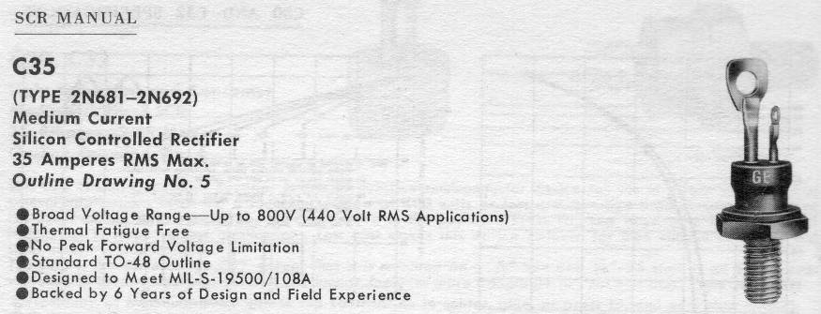

Silicon Controlled Rectifier available to Industry and Military in 1958

With these new solid state components at hand Marion & ‘Boot’ Mallory were off and running. Their first beta-test race track CD ignition system was introduced in limited quantities in the fall of 1961. Their first after market production models did not reach distributors until 1964. It took 3 years of detailed development and waiting for the SCR market to settle down before deciding on a final production design. While the basic operating principles of a CD ignition circuit is straight forward getting a long-life circuit that will function well when exposed to the temperature, voltage, and vibration extremes is a different matter. At that time in our country’s industrial heritage new products were not generally rushed, half-baked, to the re-sellers because of some imaginary dead-line imposed by the bean-counters in the marketing department.
So, in the time frame of 1960 to 1970 where could Mr. Gray have gone when he needed some rare applied technical expertise on battery operated High Voltage pulse systems? The solution seems almost obvious.

We have no doubt that Mr. Gray and ‘Boot’ Mallory were on a first name basis. They may have already developed some kind of relationship while the company was still in Detroit, we don’t know when they first got together. We do know that Mr. Gray was provided with some significant venture capital along with the fruits of 10 or so years of proprietary field tested solid state CD technology.

It has been pointed out, by knowledgeable sources, that all of the Mallory’s after market ignition systems used power transistors for the 6-12V to 450V converter section. So, we wonder, why was Mr. Gray still using obsolete vibrator packs in 1973? ‘Boot’ would have certainly supplied Mr. Gray with the most modern equipment, along with the SCR and Ignition-Coil components in a small, self contained, custom engineered, and de-bugged package.

We suspect that ‘Boot’ did provide these complete transistorized CD systems and that Mr. Gray was eagerly looking forward to the reduced size, increased life time, and improved efficiencies that the new solid state devices promised. Especially after having to constantly fight with vibrators that kept burning out during his trial runs. But, Radiant Energy (RE) generation has its own special challenges to deal with. One major engineering issue is what to do with the Electro Magnetic Pulse (EMP) like effect that happens when a RE circuit reaches a certain power level. If all that excess energy is not properly shunted to the system common (hopefully after doing some serious work) it escapes from the circuit conductors to charge every metal object within 20’ or so of the generator. A multitude of blue-white sparks will erupt from every metallic object in a room, due to the induced high voltage. This is certainly an interesting light-show, with the lights turned off, but devastating to any near by transistor or IC that has any amount of wire connected to it. Transistors and IC’s that are stored in metalized protective bags or boxes seem to survive.

If this was the case, then we can imagine how disappointed Mr. Gray might have felt when his new transistorized converters started to fail, perhaps even catastrophically. Fortunately, and we really mean very fortunately, the SCR’s were able to survive the RE onslaught. Had this not been the case the EV Gray technology, because of the constant system failure, would have seriously fallen on its nose by 1965 and never have been able to produce the demonstrated power levels that we would so very much like to recreate. Transistors, fail because they are constructed with super thin base structures that are sensitive to moderate voltage differences. SCR’s are constructed with thick silicon layers that are relatively more rugged. However, a poorly designed trigger circuit in an RE application will still destroy a heavy duty SCR, if proper gate transient protection methods are not employed. Because of this first hand experience Mr. Gray went on to install many over-voltage protection devices in his future circuits. This is very apparent in the design of the power supply shown in his Conversion Tube Patent #4,595,975.

It appears that Mr. Gray was forced to go back and use the failure prone obsolete vibrator packs that he started out with. According to the first patent these were used for the primary DC voltage conversion. We suspect that the engineers at Mallory were enlisted to help Mr. Gray marry the vibrator pack to the SCR system. The SCR addition did help solve the failure problem by reducing the arching current across the vibrator contacts. This is not a straight forward interface and it requires some experienced electronic know-how. The challenge is balancing the limited current capacity of the vibrator to the low impedance of the SCR storage capacitor.
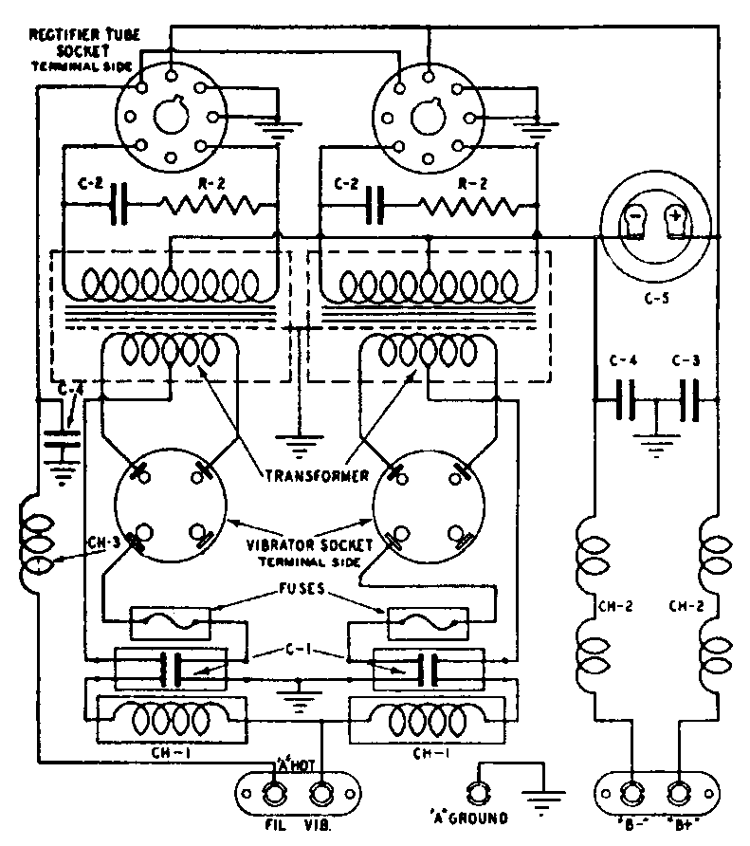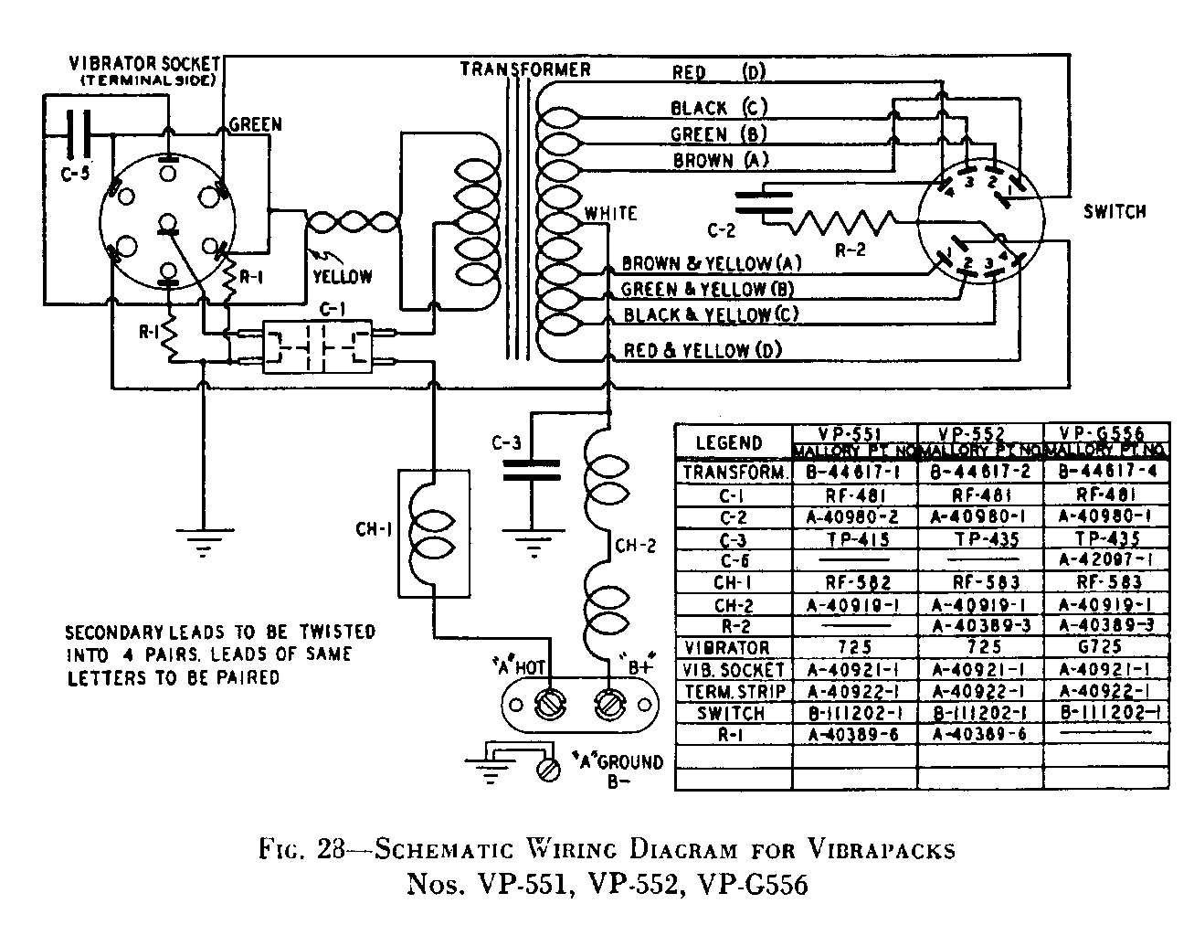

Schematic Wiring Diagrams for two P.R. Mallory Vibrapacks
60 Watt model on the left – 30 Watt model on the right

Other researchers contend that Mr. Gray never intended to use transistors in the first place. This is because one RE theory states that the non-classical process begins in the minute arcs formed during the making and breaking of the vibrator contacts. This technical issue is still open for debate and experimental verification.

However, we all agree that the SCR CD circuit is still a vital sub-system to the EV Gray technology, but it is not the whole story for a complete Over Unity (OU) process. We further believe that Mr. Gray didn’t disclose the kernel of his “secret” to ‘Boot’ or any one else at the Mallory Electric Company. It would appear that ‘Boot’, because of his unique individualistic upbringing, respected Mr. Gray’s right to his own creations. ‘Boot’ was obviously far sighted enough to see some greater business potential in this venture, not to mention a whole new class of future racing machines. One main reason for this enlightened attitude was that ‘Boot’ didn’t have to contend with a short-sighted governing board of directors whose members were more worried about next quarters stock price than taking risky chances on age changing technologies.

The CD sub-system of the Gray motor was not disclosed in patent #3,890,548. Mr. Gray did mention the use of ignition coils in the patent text, but didn’t show them in the schematic diagram. The simplest solution to help protect his “secret” was to just eliminate the CD sub-system from the schematic. Since Mr. Gray was only attempting to disclose a new type of pulse motor in this first patent. The omission of a “minor” power supply “feature” was not going to mean anything to the patent reviewers. But, the devil is in the details, especially when attempting to reconstruct this lost technology 30 years later.

There is a good possibility that Mr. Gray was returning a favor to ‘Boot’ by not disclosing the proprietary CD circuit designs. They very well could have had a gentlemen’s agreement and a joint venture on this issue. ‘Boot’ didn’t need to know Mr. Gray’s Free Energy “Secret”. His high margin piece of the action was locked in because each new EV Gray motor would need 18 or more complete CD power supplies, including the patented construction details of the Mallory ignition coils. Mr. Gray’s success was going to be ‘Boot’ Mallory’s success – BIG TIME. A classic win-win situation. It’s no wonder that ‘Boot’ willingly made out checks to this unknown and un-educated inventor from California. While the P.R. Mallory Company was unknowingly going to reap some benefit from this breakthrough the Mallory Electric Company was going to hit the jack pot.

As a purely speculative observation, it may have been ‘Boot’ Mallory who clued Mr. Gray in on how to write patents and attempt to protect one’s intellectual property form the big business lawyers. What to show and what not to show, what to draw and what not to draw and what to say the rest of the time. With this technology it was going be a feeding frenzy as soon before the first beta-test hit the street and ‘Boot’ knew it. Mr. Gray probably received a life time of inside information on how to keep secrets, make money, and cover one’s assets from a man who had been there and seen how big business really works.

We all know that Mr. Gray suffered a major setback when his research facility was raided in 1974 by the agents of the Los Angles District Attorneys Office for suspected securities fraud. But, by 1977, as shown in the photo above, Mr. Gray had recovered enough to receive his first patent, build, debug, and demonstrate his second generation motor. What is not generally known, in Free Energy circles, is that Mr. Gray suffered a far greater loss when ‘Boot’ Mallory was killed in a car wreck in 1978 at the age of 48. He was always known to be somewhat of a lead foot.

Gone was the financial, technical and morel support. As far as we can observe it appears that the EV Gray motor didn’t develop significantly much beyond the EMA6 model (above). The surviving Mallory women sold the company to Super Shops of Irvine, California in 1979. Mr. Gray continued to seek a proper level of investment capital so that he could control and manufacture his fuel-less motors in-house. He also improved on his popping-coil demonstration and updated it to a continuous process that hinted at anti-gravity possibilities, very impressive. It has also been rumored that Mr. Gray almost did collect enough money to begin production.
Unfortunately, we also know that ten years later Mr. Gray died under un-resolved circumstances in Sparks, NV in April, 1989. Sparks is just East of Reno, NV which is about 50 miles North of Carson City, NV. Some researchers contend that the main reason why Mr. Gray established one of his multiple laboratories in this town was because of the invaluable technical experience of some of the retired Mallory technicians still living in the area.
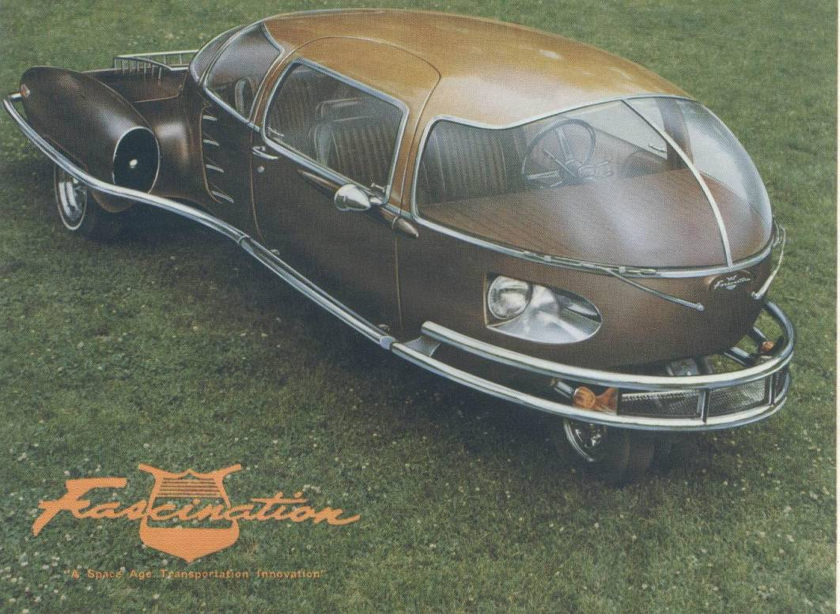

We have also been lead to believe that it was ‘Boot’ Mallory who made the first formal introductions between Mr. Gray and the alternate car inventor Mr. Paul M. Lewis, creator of the “Fascination”. You can imagine the possible creative energy that might have flowed between these three unique individuals while they were sitting around the dinner table sharing a host of far-reaching dreams and schemes.
Today, the sold and re-sold fragments of the P.R. Mallory and the Mallory Electric Company have suffered, like so many U.S. businesses, from the now common and insidious blight of globalization. Both organizations are outsourcing their manufacturing operations to China, their engineering departments to India, and their R & D efforts to Canada.
In conclusion all we can say is that this saga is truly a vital lost opportunity for the world, they were so darn close. Had this story been different we most likely wouldn’t be bankrupting our country in a vain attempt to secure oil reserves in Iraq. We could have easily had permanent colonies on Mars and not be worrying about the ongoing effects of Green House Gasses. This great country could have re-invested the trillions of our oil dollars into our own economy rather than providing excessively lush life styles for a few privileged Middle Eastern clan leaders.

